ITEC 7481: LMS Coursework Template for Meeting the Requirements of the Online Course Assessment (OCA)
Directions: Add a screen shot and/or description as needed to document your LMS design and development work in each area.
- Online Course Development [FIELD EXPERIENCE] - Candidates will use a learning management system (LMS) to develop a high-quality K-12 online course that incorporates research and best practices in online learning for children and/or adolescents. The course will contain the following:
(note: Key diversity components are italicized and underlined) - (TOTAL SECTIONS A-G = 300 POINTS)

Element |  | Screen Shot | Description
  - A Welcome Statement and Site Navigation Instructions (2.1.2); (1.1.6)
(15 points)

- Welcome Statement | Welcome!  I am excited to have you in my class. Please be sure to review the course syllabus and contact me if you have any questions or concerns. 6th grade Social Studies covers a variety of topics. Throughout the school year we will discuss the Geography, History, Governments, and Economies in Canada, Europe, Latin America, and Australia. Please be sure to check the "Update" box daily. I look forward to working with you this semester.  Mr. Carlisle  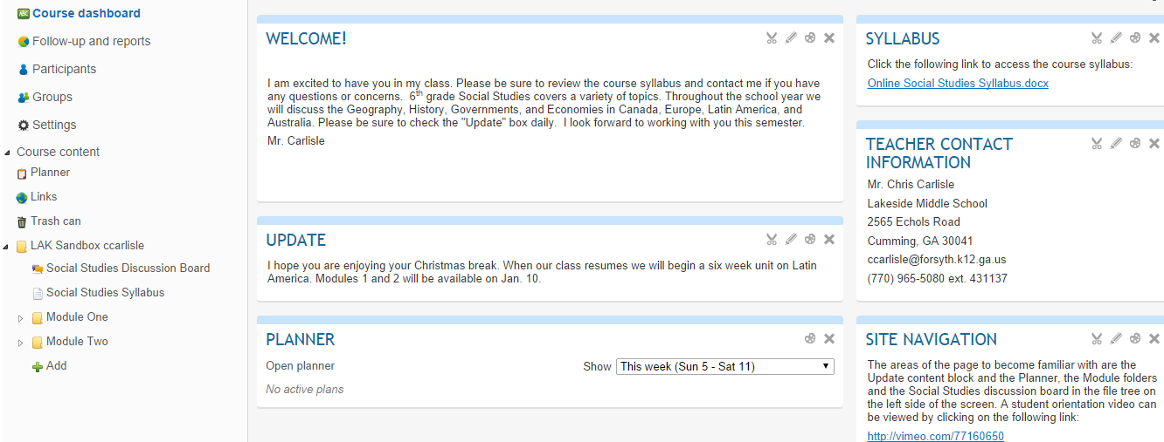 |  | This is the text in the “Welcome” content block on my LMS Course Dashboard
- Site Navigation Instructions | Log into our LMS at https://forsyth.itslearning.com/index.aspx Use your district assigned school ID and password access the site. An video overview of Its Learning for students may be accessed at  http://vimeo.com/77160650.  When you access my Social Studies class page you will see a main screen with two columns of content blocks. The three content blocks in the left column are Welcome, Update, Planner. The five content blocks in the right hand column are Syllabus, Teacher Contact Information, Site Navigation, Latest Changes, and Unread Messages. To the left you will see a file tree with folders delineating modules.  Navigation of this site will become easier with practice. The areas of the page to become familiar with are the Update content block and the Planner, the Module folders and the Social Studies discussion board in the file tree on the left side of the screen. A video in included to assist you with navigation. These page elements are visible on the screenshot of my LMS page below.  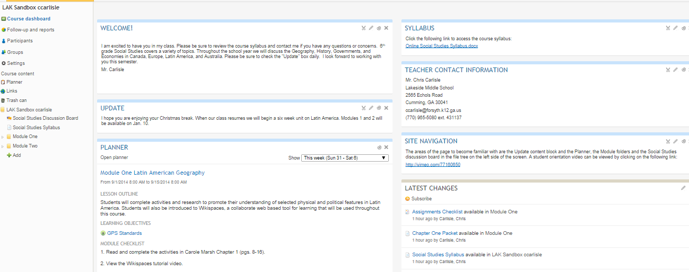 |  | I also included a screenshot of my Course Dashboard. I added a Site Navigation content block on the main Dashboard screen.  Site Navigation content block
  - Basic Support, Directions, and Guidance, including:
(30 points)

- Overview of the types and specifications of the technologies (hardware, software, and peripherals) to which students must have access in order to complete the course (Note: Required technologies and specifications should be reasonably accessible to students in order to ensure equitable access to digital content employed in the course) (1.1.1); (2.1.6) | 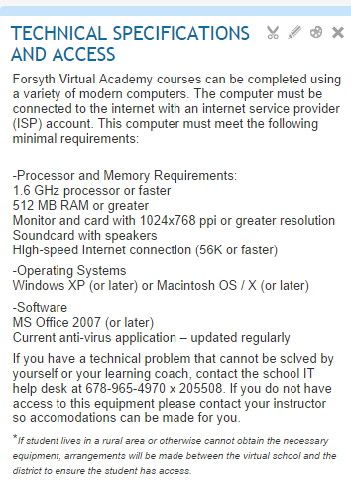 |  | Technical Specifications content block added to my welcome screen. This information is also available in the syllabus.
- Ideas for gaining access to these technologies via public or low-cost means should a student not have home access to the necessary technologies for the course (1.1.1); (1.1.7); (2.1.6) | [Insert Screen Shot]  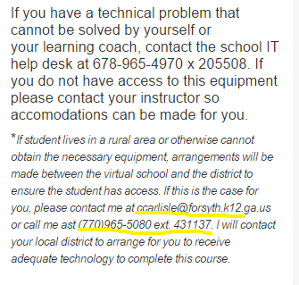 |  | If student lives in a rural area or otherwise cannot obtain the necessary equipment, arrangements will be made between the virtual school and the district to ensure the student has access.  Contact information added to help students who do not have a computer. They are to contact the instructor (myself in this case). The instructor will then make arrangements with the local school to overcome any problems with lack of access. (borrow a laptop from the school district the virtual school student would normally attend, allow the virtual student to come to the brick and mortar school to use the computer, provide transportation to a public library where a computer may be accessed for no charge.
- Overview of technical skills needed to successfully complete the course (1.1.1); (1.1.7); (2.1.6) | [Insert Screen Shot]  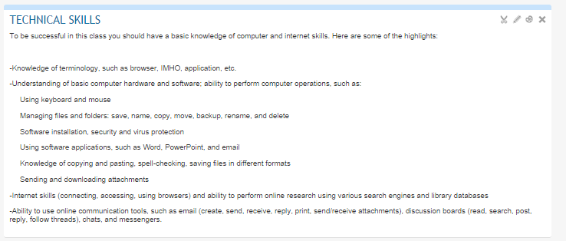 |  | This content block was added to a new page titled  On Line Learning Information and Support.
- Links to technical documentation and online tutorials to assist students in acquiring the technical skills needed for the course (1.1.1); (1.1.7); (2.1.6) | [Insert Screen Shot]  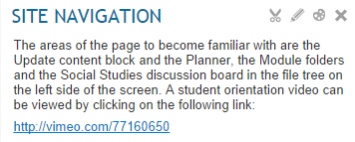  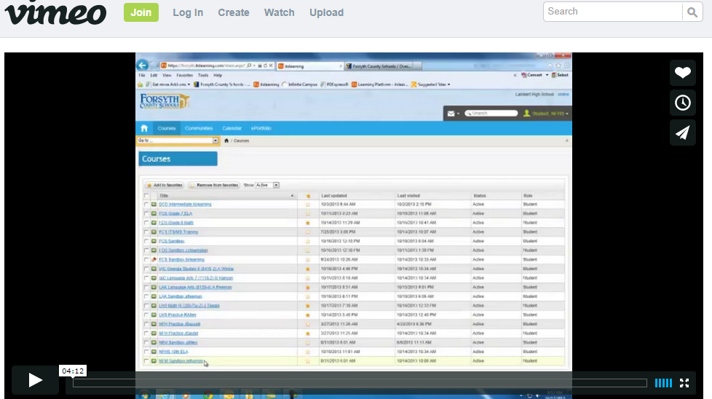 |  | This link opens a tutorial and technical assistance to navigate the LMS. This tutorial also has a plethora of links to teach students how to use many different types of productivity software.  Screenshot of district created LMS navigation and support page. This site also links to numerous tutorials to acquire technical skills students need to be successful in a virtual class.
- Links to technical support resources and directions to assist students in case of technical difficulties with LMS or with course content (1.1.7); (2.1.6) | [Insert Screen Shot]  See screenshot and description for B4.  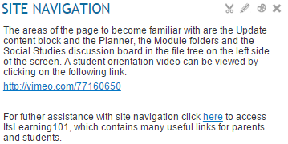  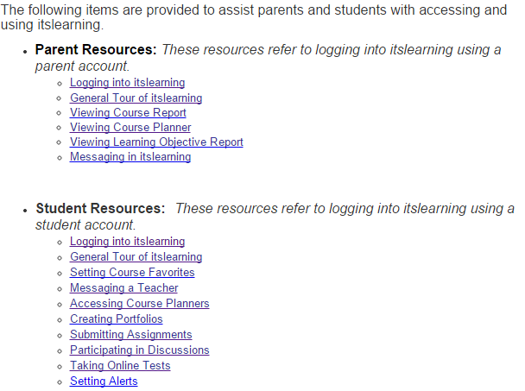 |  | Technical support, resources, and directions to assist students are included on the page from B4  This link opens up to a page with multiple links for technical support related to course content and technical difficulties.
- ADA-compliance statement by the LMS publisher (2.1.6) | [Insert Screen Shot]  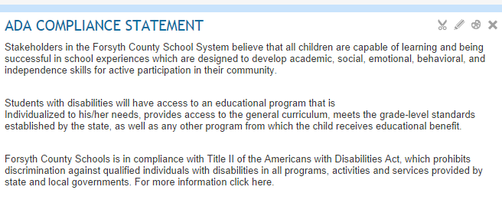 |  | District ADA compliance statement. This screenshot was taken from my On Line Access and Technical Information “page” accessible from the main course dashboard. (my dashboard was getting too full so I’m going to move some of the “access,” “navigation,” and technical information on to this page.
- Instructor statement on how universal design principles were applied in constructing the specific course within the LMS and class-specific instructions on how students with documented ADA disabilities can access the course content/receive required support services (2.1.6) | [Insert Screen Shot]  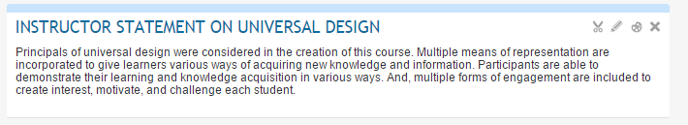 |  | My UD statement
- Instructions how students who believe they may have an ADA disability can receive testing and diagnostic services (2.1.6) | [Insert Screen Shot]  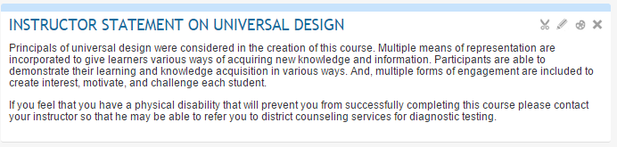 |  | Instructions for students who believe they have a disability.
- Definitions of Netiquette and expectations for teacher and student behavior in online discussions, email, synchronous meetings, and other forms of communication to be used in the course (2.1.6), (3.2.1) | [Insert Screen Shot]  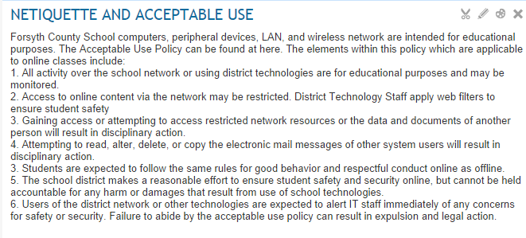 |  | Acceptable Use and netiquette statement from my On Line Learning and Support Page
  - Community Building Activities, including:
(15 points)

- Instructor introductions (2.2.2); (2.6.3) | [Insert Screen Shot]  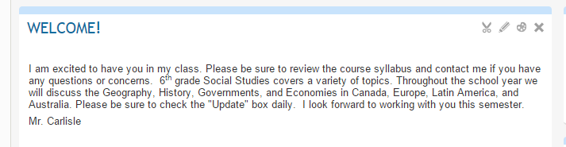  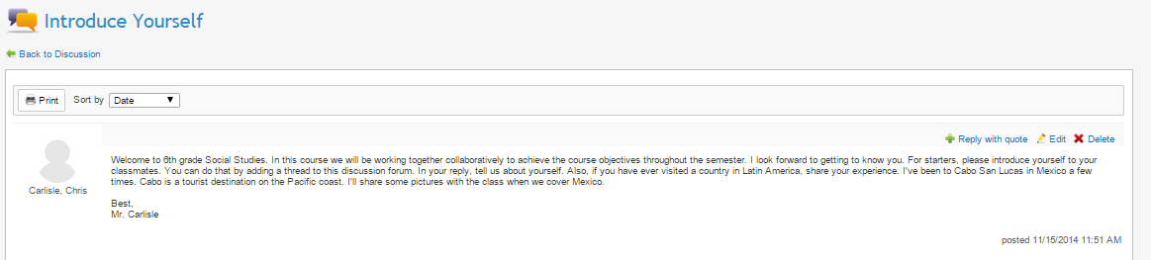 |  | Instructor Welcome message from home screen dash board.  Instructor introduction discussion post.
- Methods for students to introduce themselves to one another and to set foundations for an accepting learning community, that values diversity among members (2.2.2); (2.6.3) | [Insert Screen Shot]  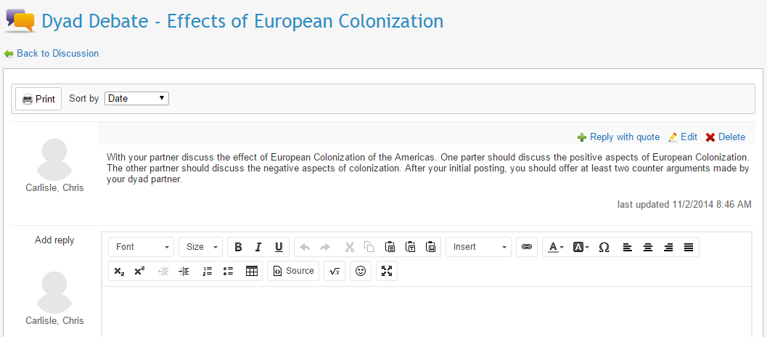 |  | Methods for students to introduce themselves are included in the “Introduce Yourself” discussion post.  Screen shot of discussion board thread. Students get to know one another. Students are paired with students from different cultural backgrounds as a means of promoting diversity among learners.
- Methods for students to provide instructor and peers with information about their current knowledge on the content to be covered, their personal/professional experiences, and their learning styles/preferences (2.2.2); (2.6.3); (3.2.1); (2.3.1) | [Insert Screen Shot]  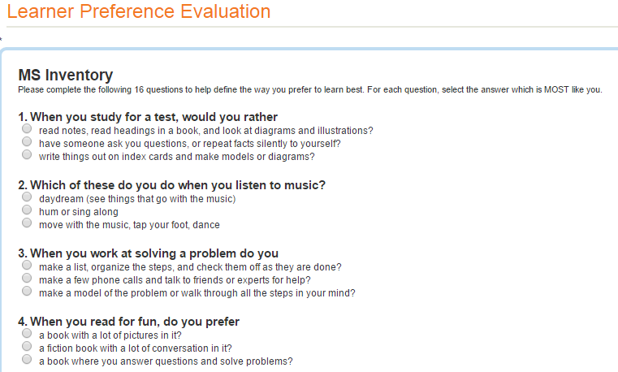  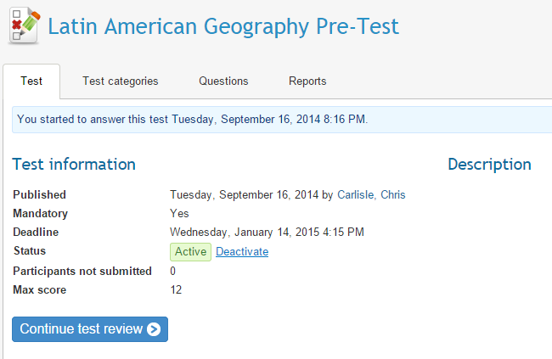 |  | This screenshot is page one of my district’s Learner Preference Evaluation. This tool is embedded in ItsLearning and gives teachers and students information about the preferred learning preferences.  Pre-test to be given at the beginning of module one. This will provide information for instructor about students’ current knowledge
  - Course Syllabus and Orientation to Course Syllabus, including:
(45 points)

- Terms of class interaction for both teachers and students, including attendance policy for synchronous activities (2.2.3); (2.2.4) | [Insert Screen Shot]  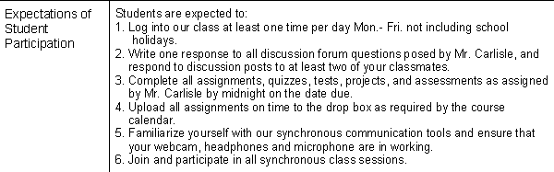 |  | Student participation expectations syllabus screenshot.
- Teacher contact information and guidance (2.2.3); (2.2.4) | [Insert Screen Shot]  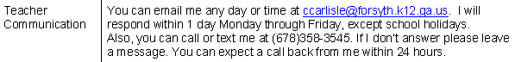 |  | Teacher contact information screenshot from syllabus
- Information on teacher response time to questions and assignments (2.2.3); (2.2.4) | [Insert Screen Shot] |  | Information about my response time for student inquiries.
- Information on how to receive instructional support from teacher and other support services, as appropriate (2.2.3); (2.2.4) | [Insert Screen Shot]  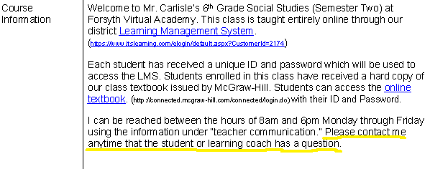 |  | This is a screenshot from my syllabus that details how students may receive instructional support from me. If a student student or learning coach needs support they should ask me directly either through email, through a telephone conversation, or during an online synch session.
- Grading criteria (2.2.3); (2.2.4) | [Insert Screen Shot]  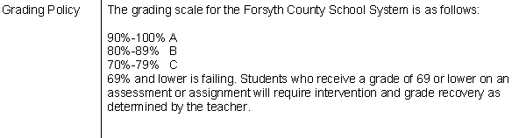 |  | Syllabus screenshot of grading criteria
- Policy for submitting and grading late assignments (2.2.3); (2.2.4) | [Insert Screen Shot]  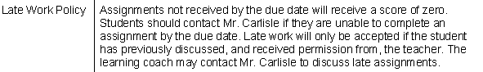 |  | Syllabus screenshot of my late work policy.
- Academic honesty and copyright/privacy policies (2.2.3); (2.2.4) | [Insert Screen Shot]  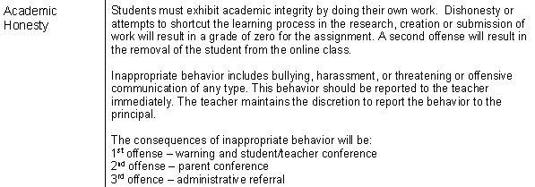  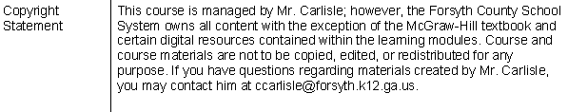  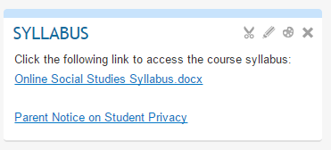 |  | Syllabus screenshot of academic honesty policy  Syllabus screenshot of copyright/privacy policy  Link to FERPA statement. . This was added based on Dr. Fuller’s feedback ITEC 7481 Module 7.
- Appropriate behavior expectations (2.2.3); (2.2.4) | [Insert Screen Shot]  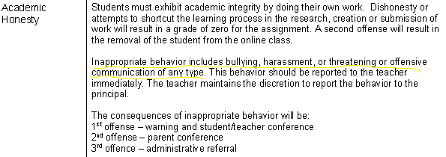 |  | Student behavior expectations underlined in yellow.
- Consequences for violating academic honesty, copyright/privacy policies, and behavior expectations | [Insert Screen Shot]  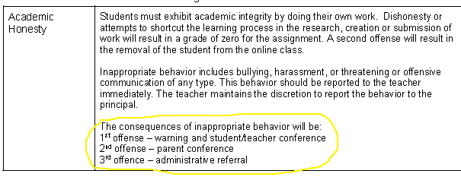 |  | Consequences circled in yellow.
- Clear, measurable course goals and learning modules objectives (2.2.3); (2.2.4) | [Insert Screen Shot]  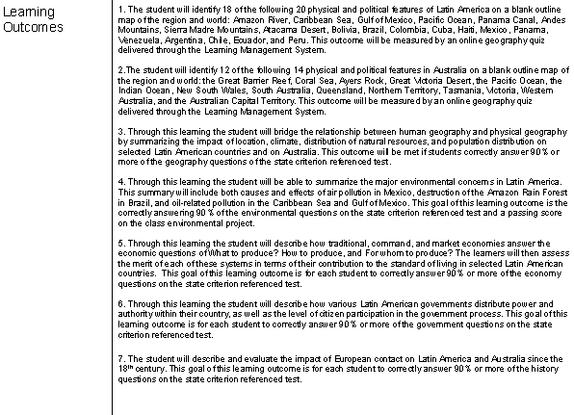  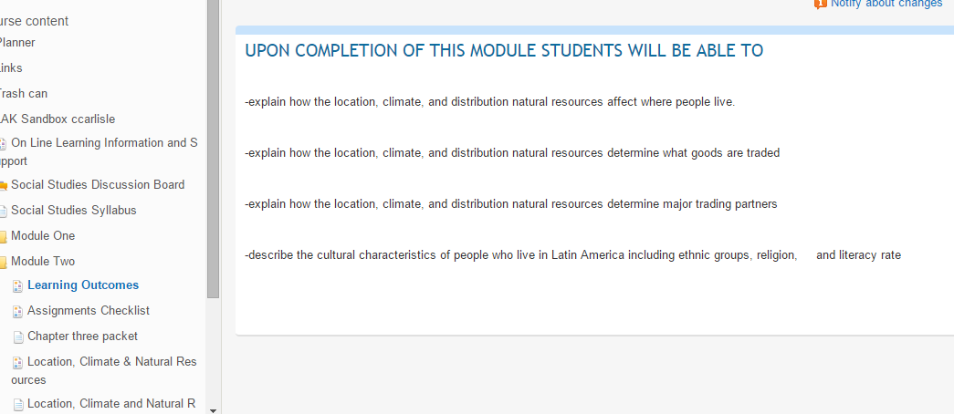 |  | List of learning outcomes taken from syllabus. Each outcome is clear and measurable.  “Learning Outcomes” for Module two. (Learning Outcomes are synonymous with “module objectives” in this unit plan. This was added based on Dr. Fuller’s feedback ITEC 7481 Module 7.
- Course schedule (2.2.3); (2.2.4) | [Insert Screen Shot]  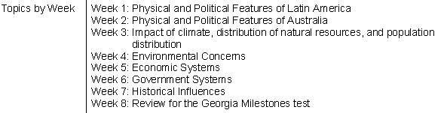 |  | Schedule is broken down into weeks.
- Required assignments (2.2.3); (2.2.4) | [Insert Screen Shot]  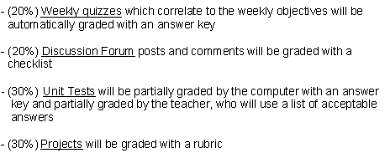 |  | List of required assignments with weighted percentages.
- Procedures for submitting assignments (2.2.3); (2.2.4) | [Insert Screen Shot]  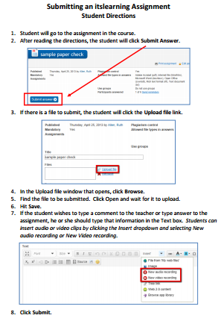 |  | All assignments are expected to be submitted by the due date. My late work policy is clearly defined in my syllabus. Attached is a screen shot on how to submit assignments in It’sLearning.
- Alignment grid showing how assignments, assessments, and standards-based learning goals are related to one another (2.5.1); (2.5.5) | [Insert Screen Shot]  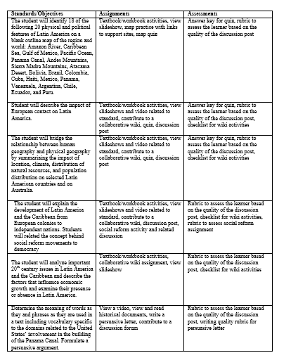 |  | This document maps how course learning goals, assignments, and assessments are linked.
  - Learning Modules (at least three) that:
(105 points)

- Clearly outline required learning activities that will help students achieve learning standards associated with the module (2.5.1) | [Insert Screen Shot]  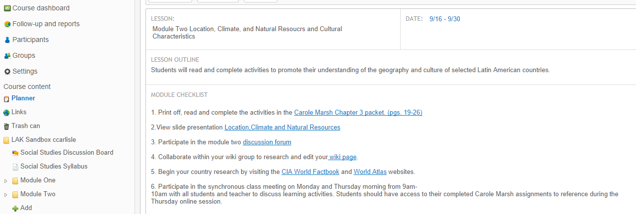 |  | Screenshot of planner for module two. This information is also available in the module two folder.
- Provide authentic, relevant, and real-world learning experiences for students to engage with content (2.5.6); (2.6.4) | [Insert Screen Shot]  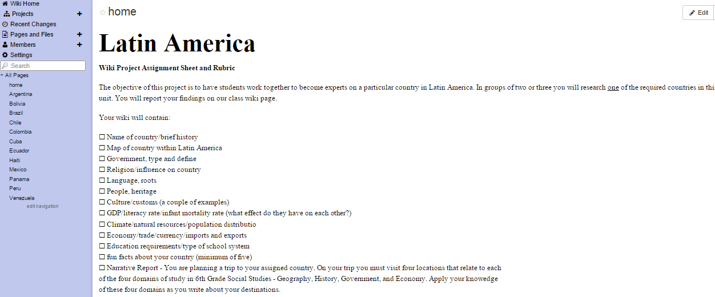 |  | Screenshot of Group Wiki home page. The activities in this project based learning experience are designed to address real world issues, which require students to investigate and analyze their complexities and interconnections.  By completing this project students will acquire an integrated understanding of the concepts and knowledge they learn. Also, the research and collaborative requirements of the project will equip them with practical skills they may use throughout their lives. The first twelve tasks are achieved through research and the last task – the narrative report – requires application and synthesis of newly acquired knowledge. Students are given a problem to solve (choose four destinations) and they must apply their knowledge by relating it to the four domains of Social Studies.
- Provide opportunities for meaningful instructor-student and peer-peer interaction to support learning (2.6.3) | [Insert Screen Shot]  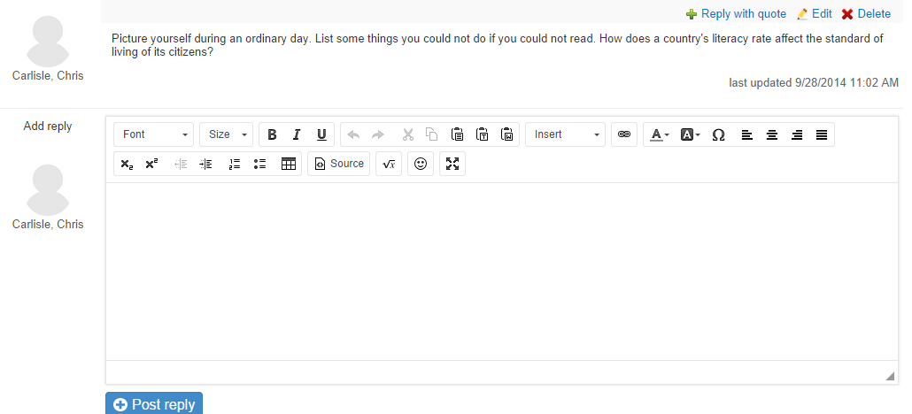 |  | Screenshot of module two discussion board. This type of discussion question provides an opportunity for student-instructor interaction as both will be engaged in the thoughtful postings and replys. Student response requirements are detailed in the syllabus and assessed using a rubric.
- Appropriately use both synchronous and asynchronous learning opportunities to support learning (1.1.4) | [Insert Screen Shot]  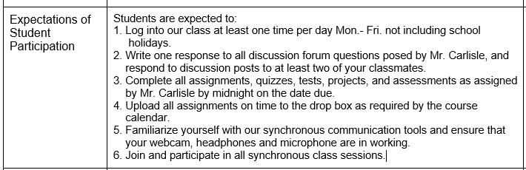 |  | Students will have both synchronous and asynchronous activities each week as described in this screenshot from the course syllabus.
- Incorporate visual resources into online modules (1.1.3) | [Insert Screen Shot]  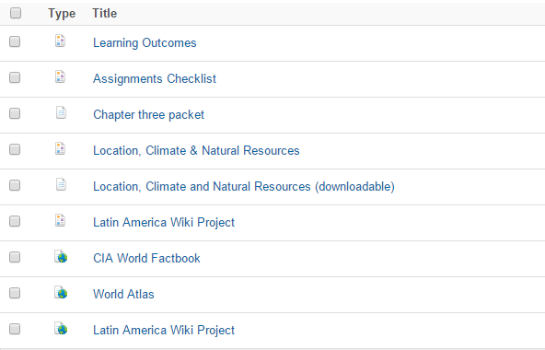  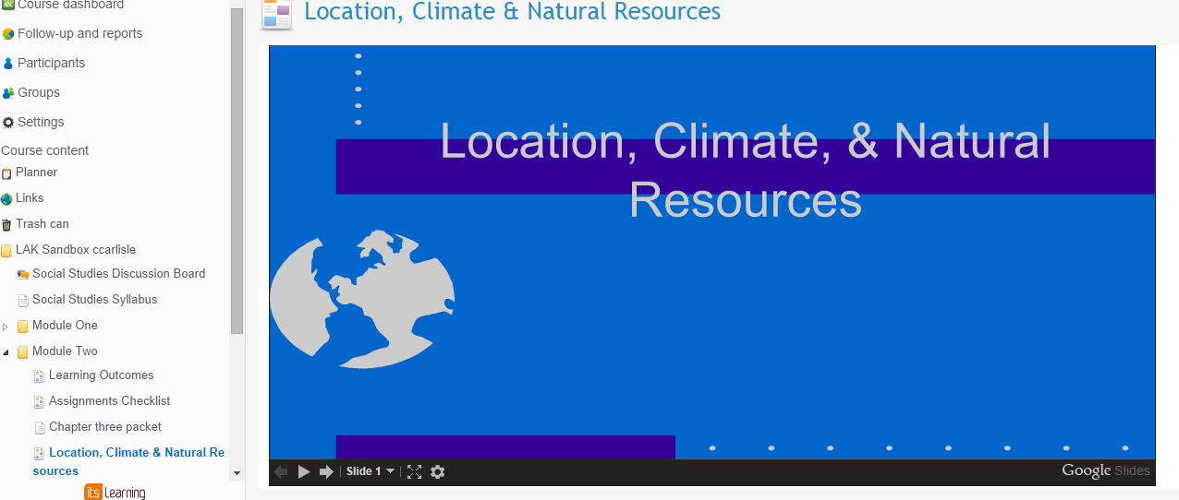 |  | Module two items – many of which are visual resources.  Screenshot of page one of a Google Slides presentation embedded into LMS module two.
- Effectively use and incorporate subject specific developmentally appropriate software in an online learning module (1.1.6) | [Insert Screen Shot] |  | Some examples of subject specific, developmentally appropriate software used in this unit –  World Atlas  CIA World Factbook  Wikispaces
- Engage students in active roles in their learning process and opportunities to construct meaning (2.6.5) | [Insert Screen Shot]  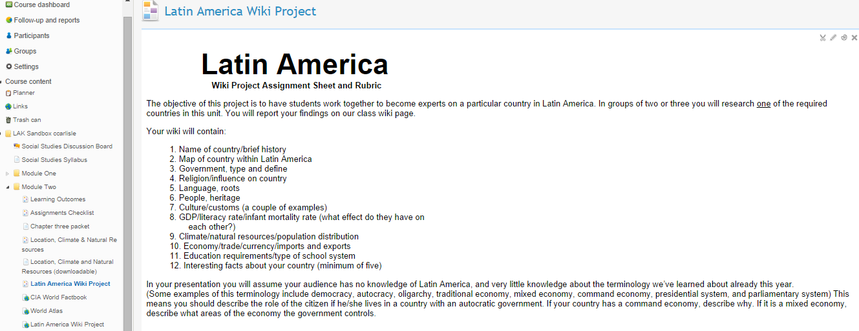 |  | Through their participation in this project, students will play an active role in the learning process and have opportunities to construct their own meaning through research as they become experts on the topic.
- Elicit a response from the student comparable with the level of competency demanded in a related task (2.5.6) | [Insert Screen Shot]  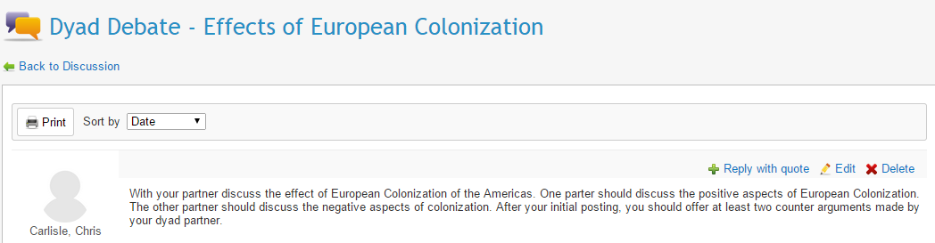 |  | Discussion posting will elicit a response from students. It’s comparable to other types of questions asked in the discussion area and other course assignments in that students read for understanding prior to their response.
- Assist students to consider meaning, reflect on new knowledge, and assimilate/apply information (2.6.5) | [Insert Screen Shot]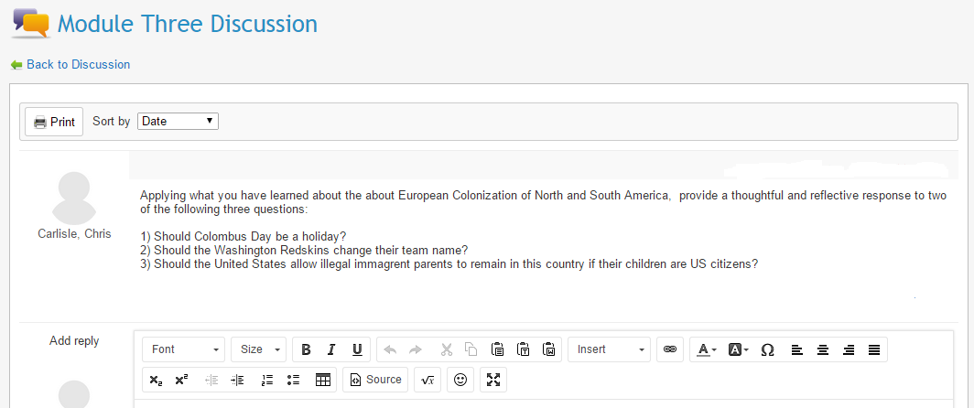 |  | This screenshot of a discussion prompt asks students to consider meaning, reflect on new knowledge, and apply information. Student discussion posts are assessed with a rubric.
- Apply technology to engage students in higher-order thinking skills and creativity (2.1.11) | [Insert Screen Shot]  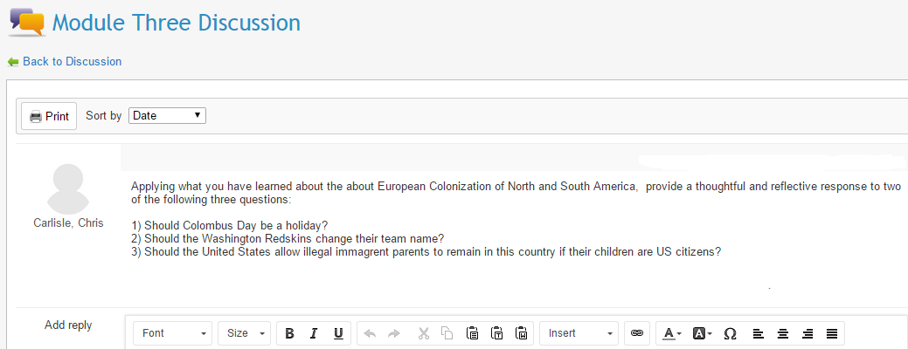 |  | As this unit is conducted mostly online, the use of technology is embedded. In other words, students who are in this class are already expected to know how to apply their technology skills. This standard then boils down to – are higher order thinking skills elicited? As evidence of this question I offer a screen shot I used previously.
- Differentiate instruction based on students’ diverse talents and learning needs (2.1.9); (2.6.1) | [Insert Screen Shot]  1. Students will read and complete the activities in Carole Marsh chapters 15 (pgs. 60-66)  2. Students will view a PowerPoint presentation related to module objectives  3. Students will participate in the module discussion forum.  4. Discovery Education Streaming Video – Hernan Cortes and the Aztec Empire  5. Discovery Education Streaming Video – Francisco Pizarro and the Incas  4. Students will collaborate within their wiki group to research material and add/edit content on their wiki page.  5. Students will complete a close read activity on Hernando Cortes.  6. Students may listen to an audio recording of the close read activity. |  | Data collected from our Learning Style inventory will give the teacher information on student learning needs and preferences. Flexible grouping strategies will then be used for group projects to ensure that each individual is paired with others who complement his/her learning style.  Students will also be given choices in how they show their knowledge. With teacher approval, students may create presentations in a variety of medium.  Differentiation through process occurs thorough providing information in multiple ways. This list of module three activities shows that students can 1)read about 2) view a slide presentation, or 3) watch/listen to a video about European Colonization of Latin America.
- Differentiate instruction based on students’ special education modifications, age, cultural and linguistic background, academic achievement, cultural background, and experiences (2.6.1); (2.6.2) | [Insert Screen Shot]  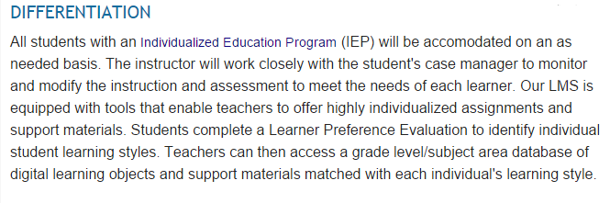 |  | Screenshot of differentiation statement taken from LMS.
- Address multiple intelligences, including the needs of visual, auditory, and tactile learner (2.5.2), (2.5.7) | [Insert Screen Shot]  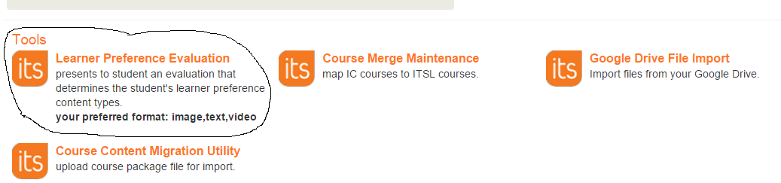  1. Students will read and complete the activities in Carole Marsh chapters 15 (pgs. 60-66)  2. Students will view a PowerPoint presentation related to module objectives  3. Students will participate in the module discussion forum.  4. Discovery Education Streaming Video – Hernan Cortes and the Aztec Empire  5. Discovery Education Streaming Video – Francisco Pizarro and the Incas  4. Students will collaborate within their wiki group to research material and add/edit content on their wiki page.  5. Students will complete a close read activity on Hernando Cortes.  6. Students may listen to an audio recording of the close read activity. |  | Screenshot of Learner Preference evaluation tool in the Tools section of our district LMS.  List of Module 3 activities which provide content in multiple modes.
- Include appropriate citations and ethical/legal use of copyrighted material | [Insert Screen Shot]  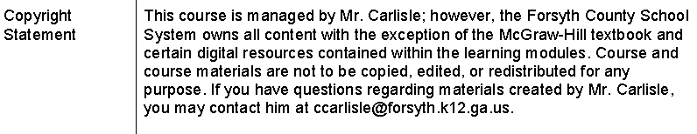 |  | Screenshot taken from syllabus.
  - Assessments of Student Learning that:
(60 points)

- Make evaluation criteria CLEAR to students through well-constructed, rubrics, checklists, grading forms, etc. (3.1.1) | [Insert Screen Shot]  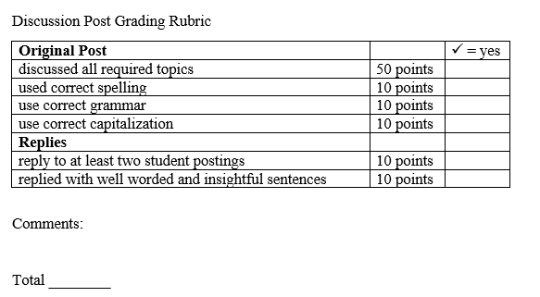 |  | Screenshot of my 6th grade discussion post checklist.
- Address ALL learning standards associated with the course/learning modules (2.5.1) | [Insert Screen Shot]  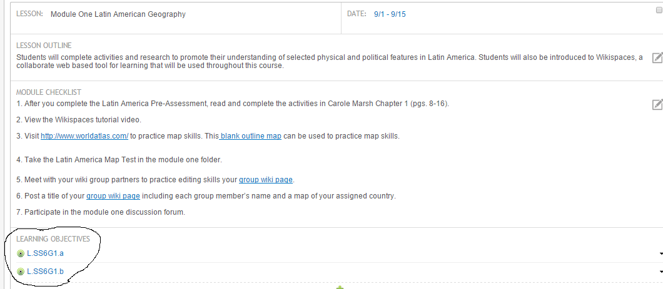 |  | Screenshot of Planner page for Module One. Links circled open GPS standards addressed in this module.
- Address multiple intelligences, including visual, auditory, and tactile learning styles (2.5.2), (2.5.7) | [Insert Screen Shot]  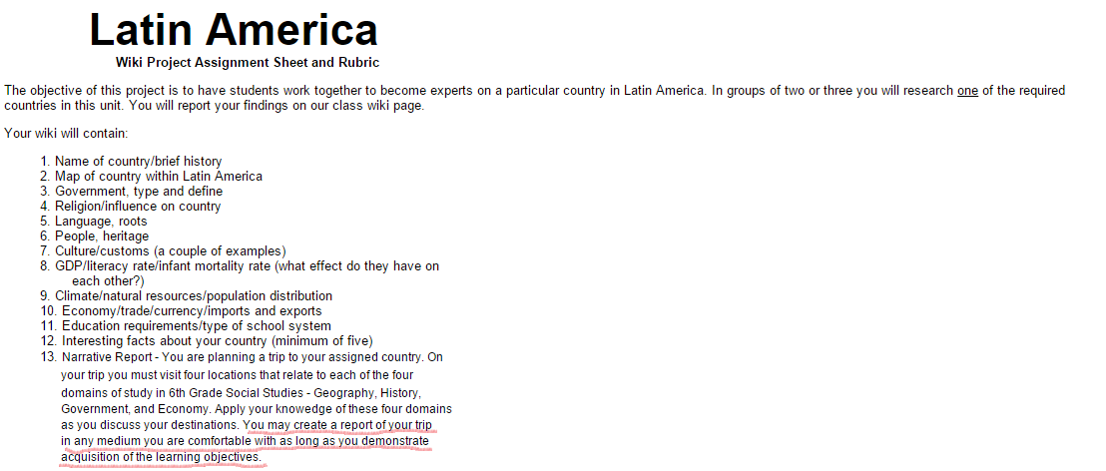  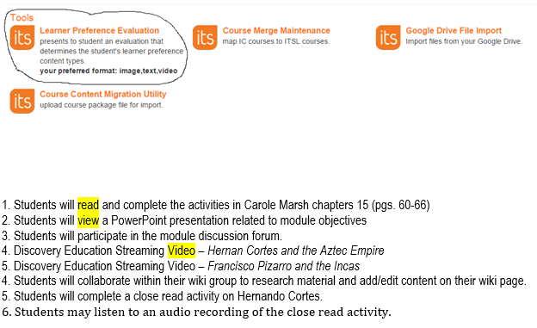 |  | Assessment with consideration to multiple intelligence and learner preference is built into Latin America Wiki Project. See underlined.
- Use authentic assessment strategies to determine student acquisition of knowledge and skills (2.5.3) | [Insert Screen Shot]  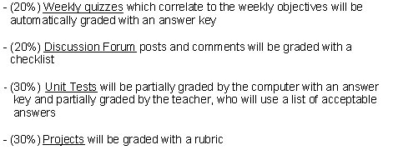 |  | A balanced assessment plan is used in this unit. Multiple choice is but a small part of overall student assessment. Screenshot taken from syllabus.
- Include pre- and post- testing to show student growth in content knowledge (2.5.5) | [Insert Screen Shot]  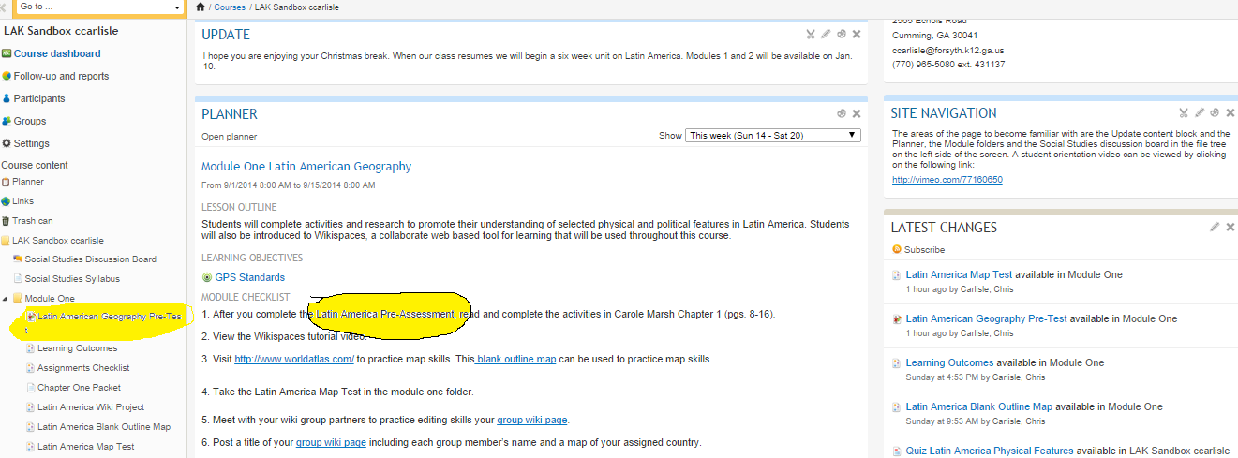  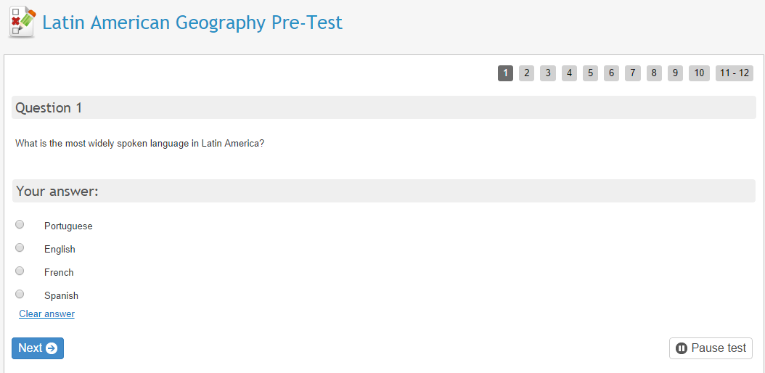  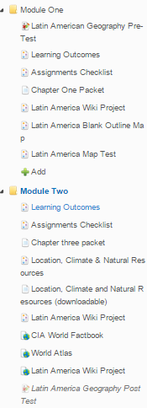 |  | Attached is a screenshot of my LMS that assesses student content knowledge of the 6th Grade Georgia Performance standards of Latin America. I used the tools in my school’s LMS, Its Learning. This screenshot directs students to the Latin America Pre-Test  This screenshot is question one of the actual 12 question multiple choice assessment.  Latin America Geography Post test is given at the end of Module two. Italics means the test is not “active.” Teacher has control when to make the test available to students.
- Are reasonable expectations given the learning activities included in the course (2.5.5), (2.5.6) | [Insert Screen Shot] |  | I don’t know how to document this requirement. I think my expectations are reasonable.
- Require students to engage in authentic performances to show mastery of content (2.5.6) | [Insert Screen Shot]  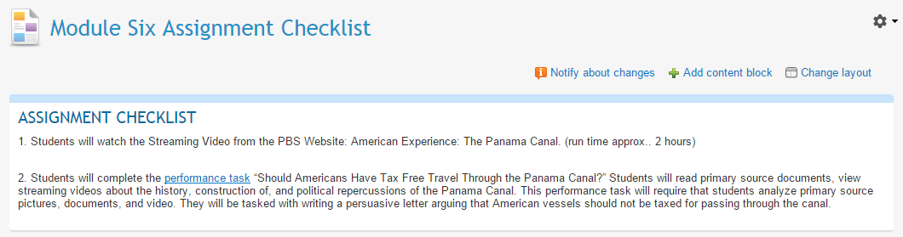 |  | Screenshot from module six. Authentic performance evidenced in this performance task.  More evidence of F7 as follows  For some people, the definition of “authentic assessment” is any assessment that is not a multiple choice test. As this screenshot suggests – multiple choice tests make up only a portion of overall student assessment in this unit.
- Are modified to accommodate special education needs, student age, cultural background and experiences (2.6.2) | [Insert Screen Shot] |  | Screenshot from LMS differentiation statement. Teacher will adhere to all accommodations outlined in student IEPs.
- Are valid (i.e., adequately sample the content that they are designed to measure) and reliable (i.e., produce consistent results from administration to administration) (3.1.1) | [Insert Screen Shot]  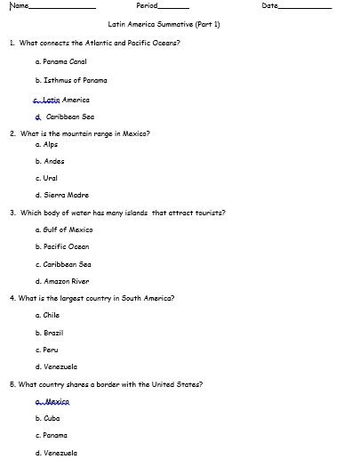 |  | This screenshot is the first five questions of a unit test I have used over the last four years. The test is valid and reliable. The full test can be found here.
- Are implemented in ways that insure instrument validity and reliability (3.1.2) | [Insert Screen Shot]  No screenshot for this item. I’m not sure how I would show evidence of this. |  | As many of the items on the unit test are repeat questions from earlier quizzes, the unit test from F9 would be considered reliable and valid based on the “test, re-test” reliability indicator.
- Include varied and multiple ways to assess each learning standard (3.1.3) | [Insert Screen Shot]  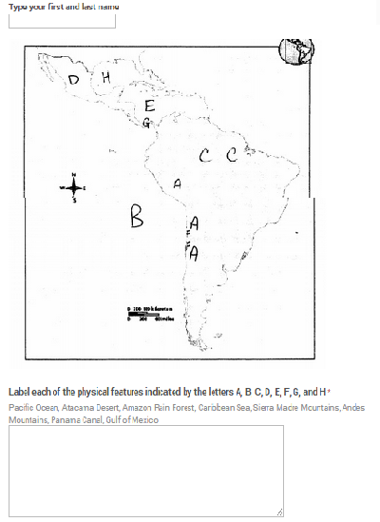 |  | Besides the multiple choice questions as seen on the test from F9, visual learners also have an opportunity to show knowledge on tests like the following:  This screenshot is an assessment I added to module one. It’s an embedded Google form where students type their name and answer the map questions in the field below the pic. The “submit” button was cut off of this screenshot.  This is an example of one of my assessment and is a type of assessment that will allow visual learners to show their knowledge.
- Gather appropriate background and content knowledge assessment data throughout the course for each student, so that instruction can be customized to students’ group and individual learning needs throughout the course. (3.3.1) | [Insert Screen Shot]  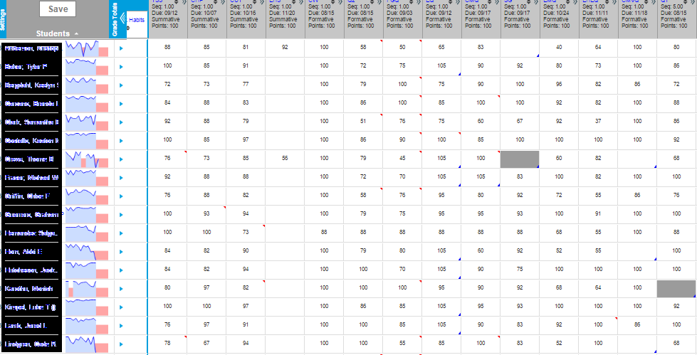 |  | Screenshot of gradebook showing student content knowledge assessment data throughout the course for each student. Data enables the teacher to individualize learning for each student based on need.
- Provide both formative and summative assessment practices, including opportunities for students to self-assess, receive peer feedback, and receive ongoing response on performance from the instructor (3.2.2) | [Insert Screen Shot] |  | Weekly quizzes – students receive immediate feedback as quizzes are graded on by computer  Discussion forum – students receive feedback from instructor based on a checklist of required items.  Unit test- students have the opportunity to do test corrections for half credit on all missed responses  Projects – students interact with and receive feedback from peers
  - Evaluation of Course Materials and Instructional Practices including:
(30 points)

- An evaluation of student readiness to engage in online learning, in general, and the specific modes of delivery used in the course (3.2.1) | [Insert Screen Shot]  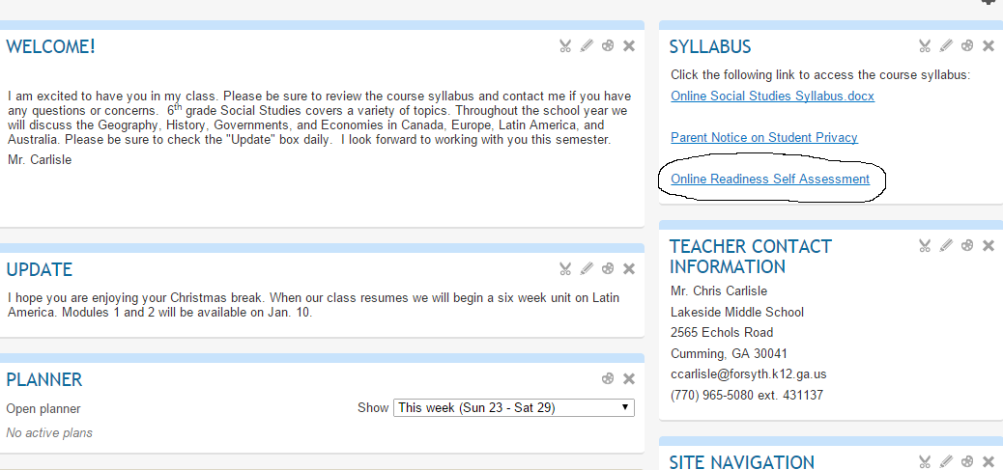 |  | Online Readiness self- assessment link
- Student input on course materials the course so that ongoing improvements to course content and delivery can be made for ALL learners (2.5.4) | [Insert Screen Shot]  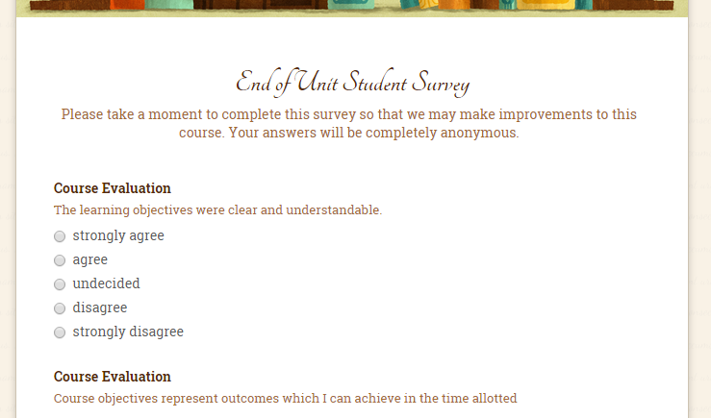 |  | Screenshot of end of unit student survey. Survey contains 15 Likert questions and two open ended response question.
- Opportunities for evaluating teaching effectiveness within the online environment (i.e., classroom assessment techniques, teacher evaluations, teacher peer reviews) so that ongoing improvements can be made for ALL learners (3.3.4) | [Insert Screen Shot]  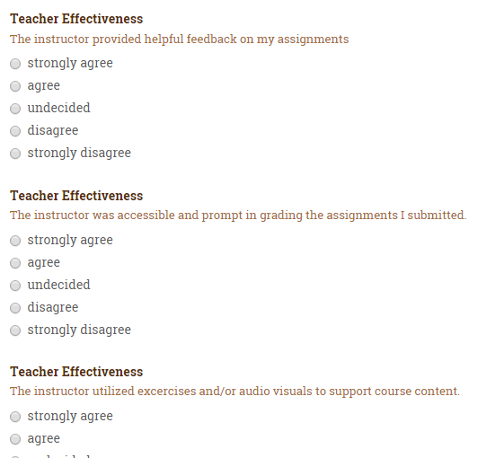 |  | Screenshot of student survey – this screenshot shows questions about teacher effectiveness

The Online Course Assessment (OCA) is completed in ITEC 7481 Designing and Developing Online Learning. It assesses the candidate’s ability to develop a syllabus for an online course in education. It assesses PSC standards (1.1.1), (1.1.3) (1.1.4), (1.1.6), (1.1.7), (2.1.2), (2.1.6), (2.1.9), (2.1.11), (2.2.2), (2.2.3), (2.2.4), (2.5.1), (2.5.2), (2.5.3), (2.5.4) (2.5.6), (2.5.7), (2.6.1), (2.6.2), (2.6.3), (2.6.4), (2.6.5), (2.6.8), (3.1.1), (3.1.2), (3.2.1), (3.2.1), (3.2.3), (3.3.1), (3.1.3)

