Managing digital tools in the context of a student learning experience
Artifact: Inclement Weather Assignments
1) Below are three screenshots of my “Planner” page on my district LMS – Its Learning. Under the activity column you can see the three assignments I created. (One for Feb. 19; one for Feb. 24; and one for Feb 25)

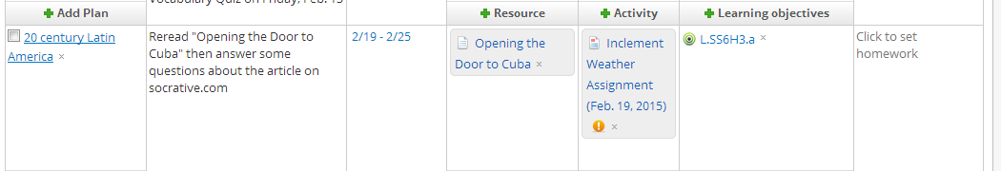
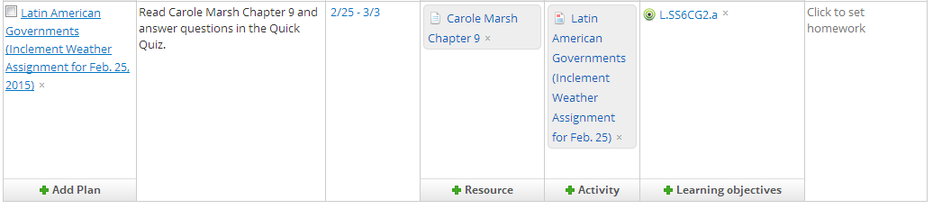

2) Below is a screenshot of the Feb. 19 assignment. A portion of this screenshot is cut off. The hyperlink “Opening the Door to Cuba” opens a shared article from my Google drive. Students had a choice of submitting their answers in the field at the bottom of the page or by logging onto m.socrative.com and answering the questions in that format. I offer this as evidence of me successfully managing digital tools to facilitate student learning.
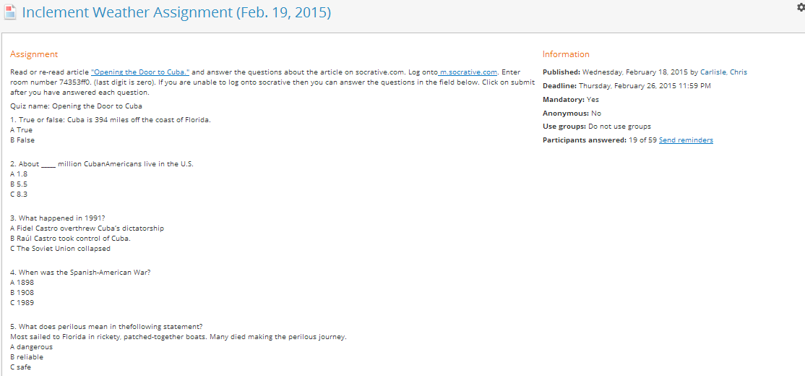

3) This screenshot shows students who have submitted assignments, and those who have not. The red shaded “not corrected” tag indicates that these students have turned in their assignment, but I have not yet graded it.

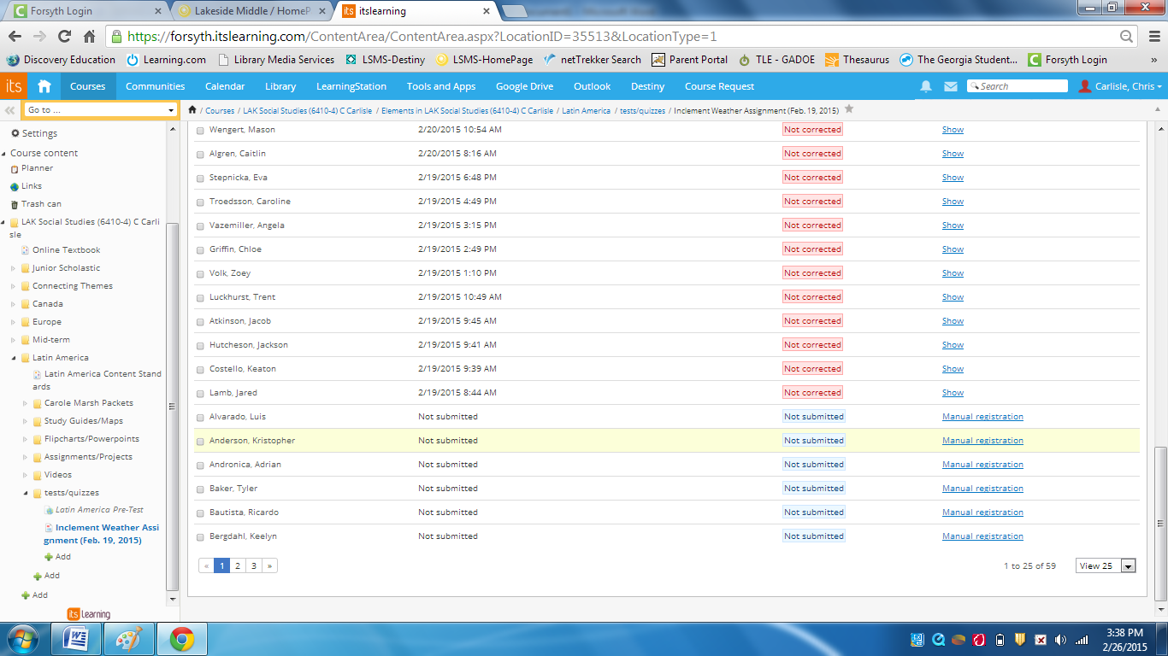

In this screenshot the green shaded “Satisfactory” indicates that I have graded these students’ submissions and provided feedback. The blue shaded “not submitted” tag indicates students who have not yet turned in their assignment. These students will receive a reminder from me about their missing work.

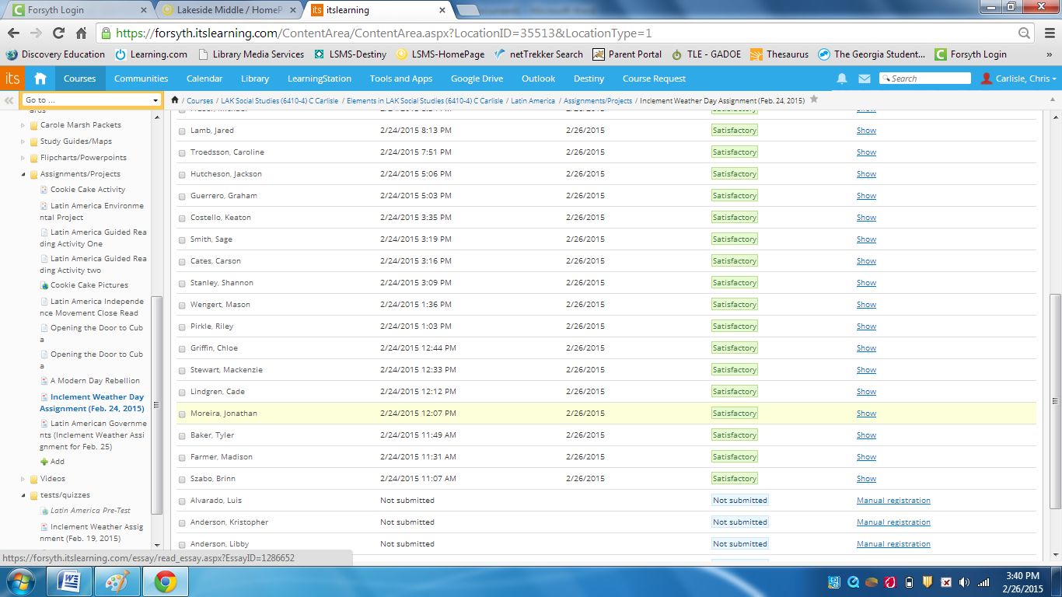

The screenshot below is another example of my ability to manage digital tools in the context of a student learning experience. In this screenshot, I provide feedback to a student’s previously submitted responses.

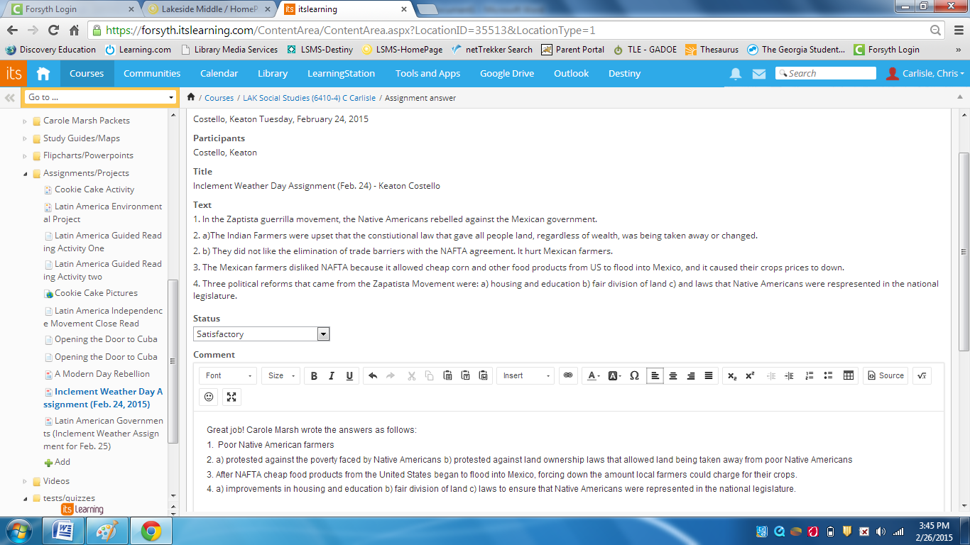

This screenshot was taken to show my ability to manage digital tools in the context of student learning. Here, I’m getting a “sharing link” which I embed into an assignment page on my district LMS. This link opens an article I required students to read during one of our “inclement weather” days in February, 2015.
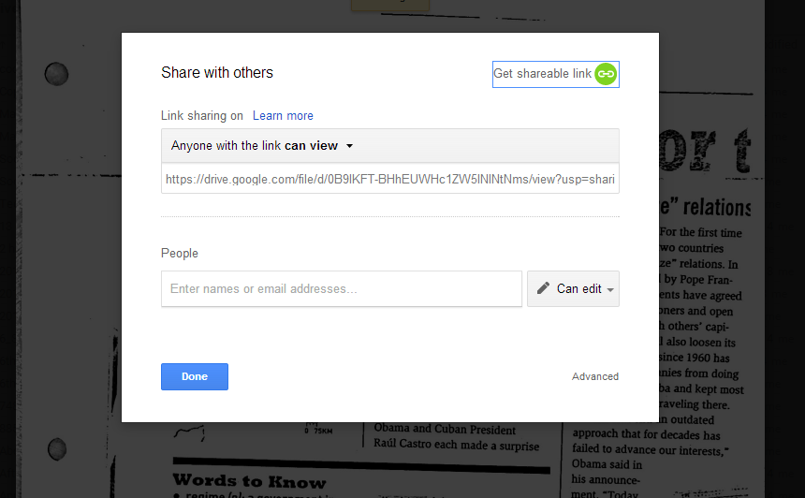

This screenshot is a report sent to me after the completion of the Feb. 19 Inclement Weather Assignment. This spreadsheet tracks student progress on an assessment I administered through socrative.com. This shows my ability to manage digital tools in the context of student learning.
